# Assignment 4: Marketing Analytics

By Preethi Susan Abraham

1. If the client had to choose one product to be their "Hero Product" (i.e., the one product their brand is known for) what would you recommend?

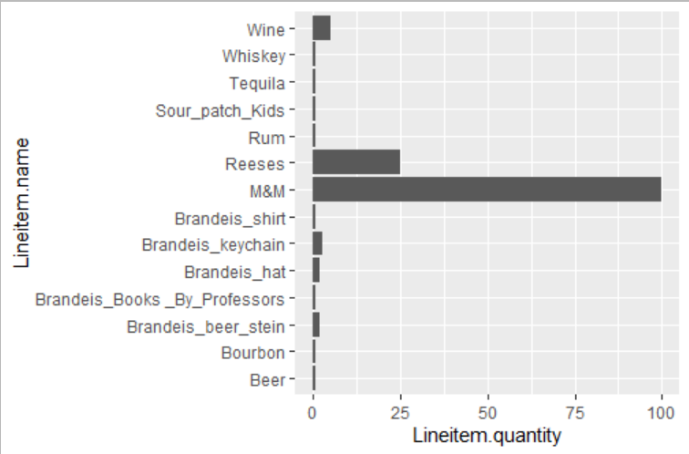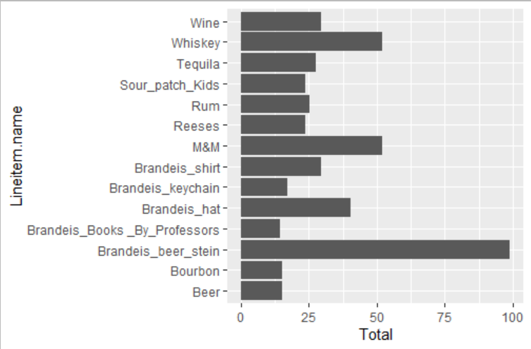

🡪 From all the items that have been paid for, it can be seen that M&Ms are sold in large quantities and they seem to be generating good income for the business. Even though Brandeis beer stein is the product which is generating the most amount of money for our client, it can be seen that not many quantities of this product are being purchased. In order to ensure that sales of Brandeis gear increases, our client should consider the Brandeis Beer Stein as the ‘Hero Product’ since promoting this product will lead to more customers purchasing it, thereby enabling the company to generate more revenue. Since this e-commerce firm focuses on selling Brandeis gear products, they should not consider products like M&Ms, Wine, Whiskey and other non-Brandeis items are their ‘Hero Product’.

2. If the client wanted to make bundles of products (i.e., groups of 2 or more products that consumers might want to buy together as a group) to sell, what two bundles of products would you recommend?

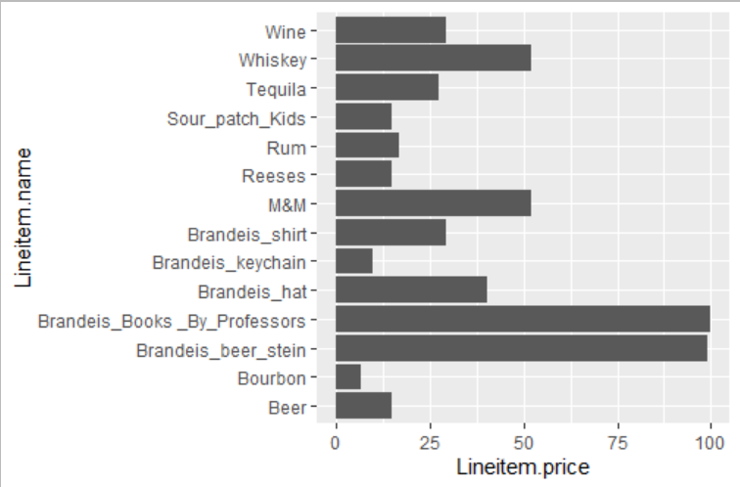

Group 1: (Beer Bonaza!)

* Brandeis Beer Stein
* Beer

These are complementary products, so it is highly likely that customers will prefer to purchase both of these together. The beer stein is one of the highest priced products whereas beer is low in price. It is likely that customers will be willing to spend on beer if they are already planning to purchase the beer stein since beer is not expensive. Since beer stein is the most profit generating product, this combination of products will increase the company’s revenue

Group 2: (Brandeis Goodies!)

* Brandeis Hat
* Brandeis Keychain
* Brandeis Shirt

Since our client’s main focus is to sell Brandeis Gear, they should create a bundle which contains different Brandeis products. It is likely that our client’s target customers are students/faculty/staff and alumni of Brandeis University. With the right advertising and pricing strategy, this bundle of products would be ideal for such customers, thereby increasing our client’s sales and revenue.

3. How would you price these bundles?

🡪 If we add the price of each line item in the bundle, the original price for Bundle 1 and 2 would be as follows:

Bundle 1: (Beer Stein + Beer)

The original price for this bundle would be $113.975 (by adding line-item price of beer stein and beer). Our client can sell this bundle for $100 and advertise this bundle by mentioning that this bundle offers a discount of approximately 12%

Bundle 2: (Brandeis Hat + Brandeis Keychain +Brandeis Shirt)

Since there are two types of hats in the dataset which are priced differently (one costs $14.4 and the other costs $40.3), the original price of the bundle would be $54.050 (with the hat which is cheaper) or $79.855(if the bundle has the expensive hat). These bundles can be sold at $50 (7.5% discount) and $69.855 (approximately 12% discount. The client can mention that by buying this bundle, customers get the keychain for free) respectively.

4. Make 3 additional insights from the data that the client could use to develop their marketing

🡪 a. Brandeis Blanket, Brandeis water bottle, Vodka and Champagne seem to be the items which are refunded or have no record of whether it has been paid for or not. Brandeis Blanket seems to be refunded. This might be because the item had some issues. Our client should look into the reason why this item got refunded. The other three items do not seem to have any form of record regarding whether they have been paid for or not.

b. Customers seem to be buying snacks like M&M’s and Reese’s from our client’s website in large quantities. Our client should consider creating another bundle with these products. A bundle with products such as Brandeis Shirt, hat and M&Ms could be popular. A snack bundle with just M&M’s and Reese’s would also be a major success for our client’s website. This bundle can be sold for $60 (giving $7 off to customers)

c. Certain items like Bourbon and Keychain are low in price. These items can be added to bundles or can be sold along with a highly priced item.